MATH STUDENT RESPONSE SHEET

Score
Name of Open Response: Hardwood Furniture Company Student Name _____________________
Type of Response: Algebraic Ideas
The Hardwood Furniture Company manufactures small tables and chairs. IT cost $30 to make each table and $20 to make each chair. The amount available to produce all the tables and chairs in one week is $1,200. Let t represent the number of tables produced and c represent the number of chairs produced.
- The equation of the cost of making furniture of r one week is 30t + 20c = 1,200. On the grid, construct a graph of this equation (with correct labels and scales).
- The Hardwood Furniture Company always produces two chairs with each table. Write an equation that represents the number of chairs (c) in terms of the number of tables (t). Graph and label this equation on the same grid used for part a.
- Determine the number of tables and chairs the Hardwood Furniture Company can produce per week based on the production cost and the amount of money available (i.e., $1,200). Round the answer appropriately.
- Explain how the answer to part c is indicated on the graph.

Scoring Guide for “Hardwood Furniture Company”

Score | Description
4 | Student scores 4 points
3 | Student scores 3 - 3.5 points
2 | Student scores 2 – 2.5 points
1 | Student scores .5 – 1.5 points  OR  Student demonstrates minimal understanding (e.g., student correctly graphs at lease two points)
0 | Response is totally incorrect or irrelevant.
Blank | Student gives no answer at all.

Score Points

Part a:
score 1 point correct graph
OR
score .5 point graph with one error or missing scales or labels

Part b:
score .5 point correct equation
AND
score .5 point correct graph based on the equation

Part c:
score 1 point .5 point each for correct number of tables and chairs
OR
score .5 point incorrect answers worked correctly from answers given in part a and part b
OR
incorrect answer(s) due to calculation error or rounding

Part d:
score 1 point correct answer

Correct Answers
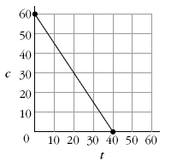
Part a:

or equivalent graph with axes reversed

Part b: c = 2t, or t = ½ c; the line should be added to the graph of part a as shown here:
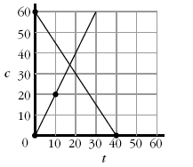

Part c: tables = 17 and chairs = 34; using c = 2t and 30t + 20 c = 1200
30t + 20(2t) = 1200
or “17 sets of tables and chairs” 70t = 1200
t 17.14
c 2(17.14) 34.28
Part d: This is (or is approximately) where the lines intersect.
Sample Released Question
January 2004 Grade 11
Systems of Equations

